**Hummingbird – C# Examples**

These files are the output from the C# Project “HummingbirdCSExample.csproj” which is included in the solution “HummingbirdUtilityHB.sln”. They illustrate the use of the Hummingbird process without the use of Rhino-Grasshopper. This could be a desired workflow or a means of testing the HummingbirdUtility.

The project creates a Windows executable file called “HummingbirdCSExample.exe” in the “..\bin\debug” folder, which can be run directly. It does not require Rhino or Revit but does depend on some of the other .DLL files in the Hummingbird code.

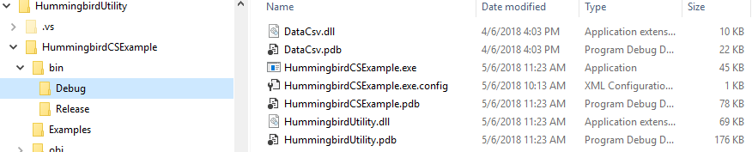

Running the program opens a menu with buttons to create the .CSV files, parameters that control how the programs control the gepometry created, and a path to where the .CSV files will be created.

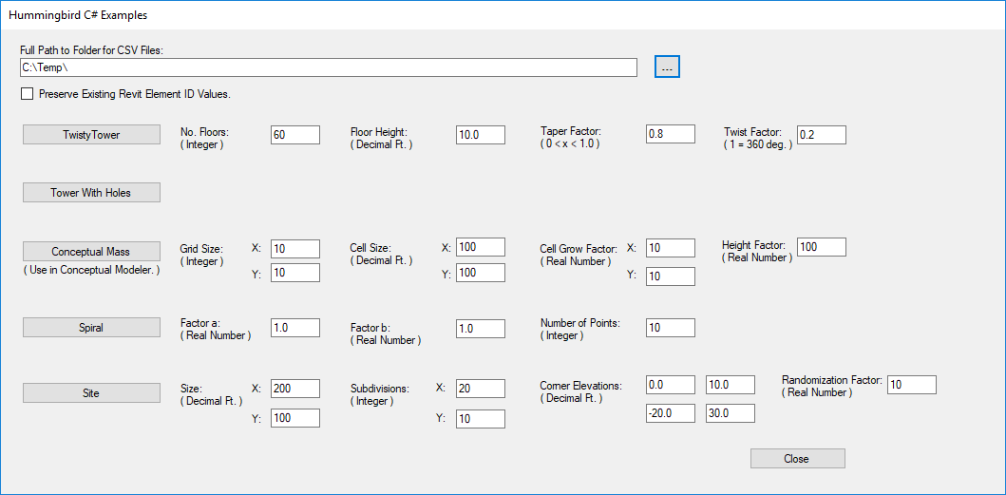

*The Menu of the C# Example Program*

The files created are:

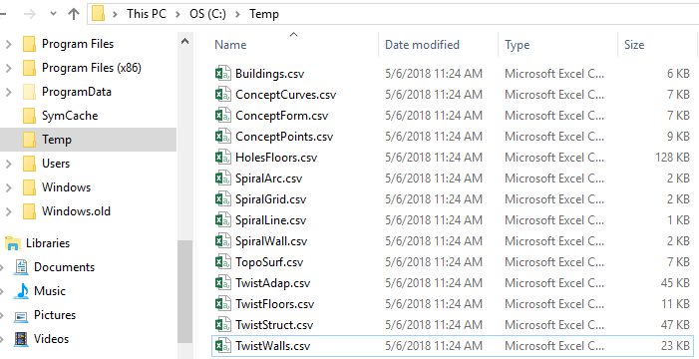

*.CSV Files Created (Using path = C:\Temp)*

There are five groups of files in the output, each of which is described in more detail in a sub-section below.

For each group, there is a Revit file that includes the completed forms. These files and can be used to demonstrate their creation by deleting the elements and then using the Hummingbird-ModelBuilder process to recreate them. Using the existing file insures that the required families are present.

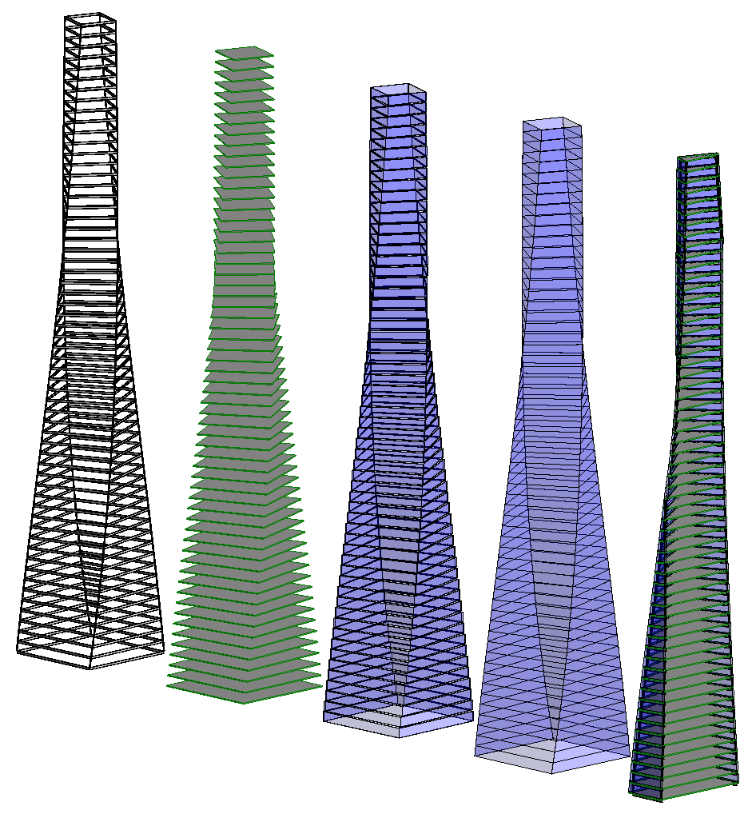

1. Twisty Tower

Uses:  
"TwistAdap.csv", "TwistFloors.csv", "TwistStruct.csv", and "TwistWalls.csv"

Test file:  
“C-SharpTwistTower2018.rvt”

Use the Revit-MocelBuilder defaults shown below

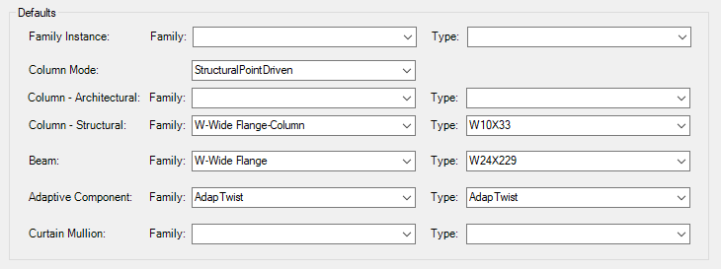

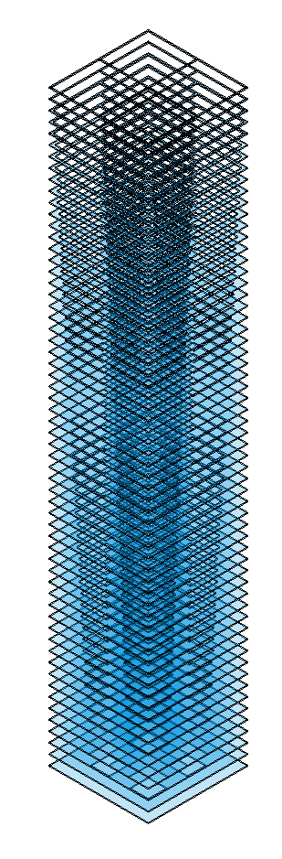

2. Tower with Holes

Uses: "HolesFloors.csv"

Test File: “C-SharpTowerWHoles2018.rvt”

3. Conceptual Mass Elements

(Must be created in a conceptual mass family.)

Test file:

Uses “ConceptCurves.csv", "ConceptForm.csv", and "ConceptPoints.csv"

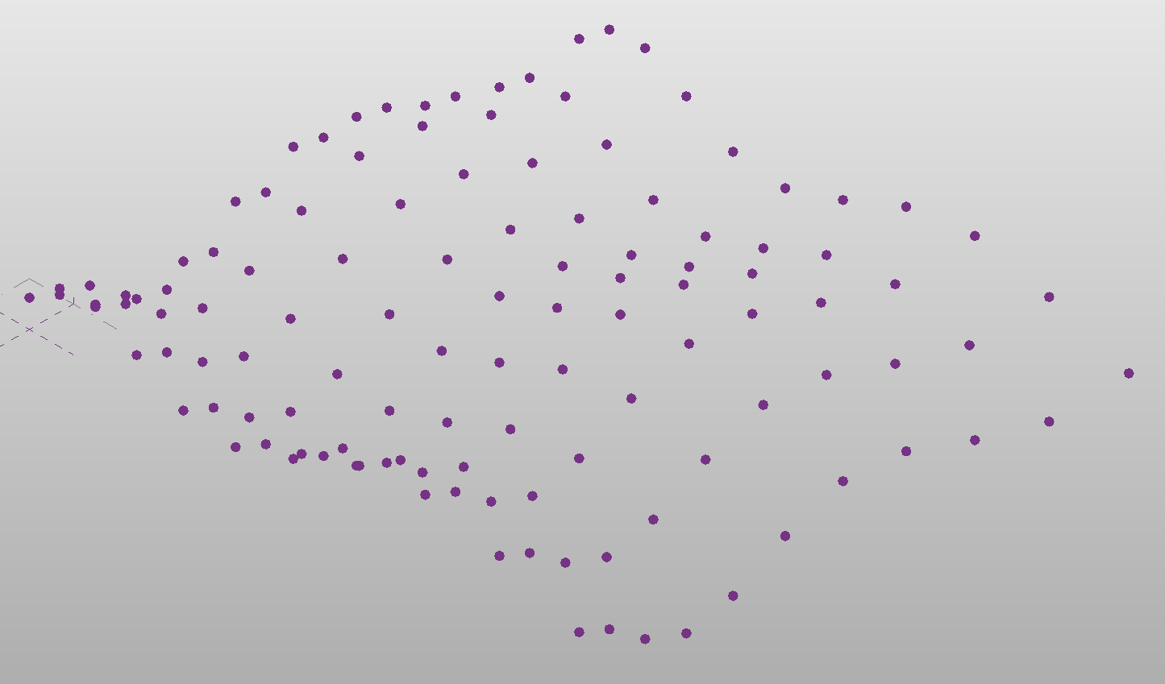 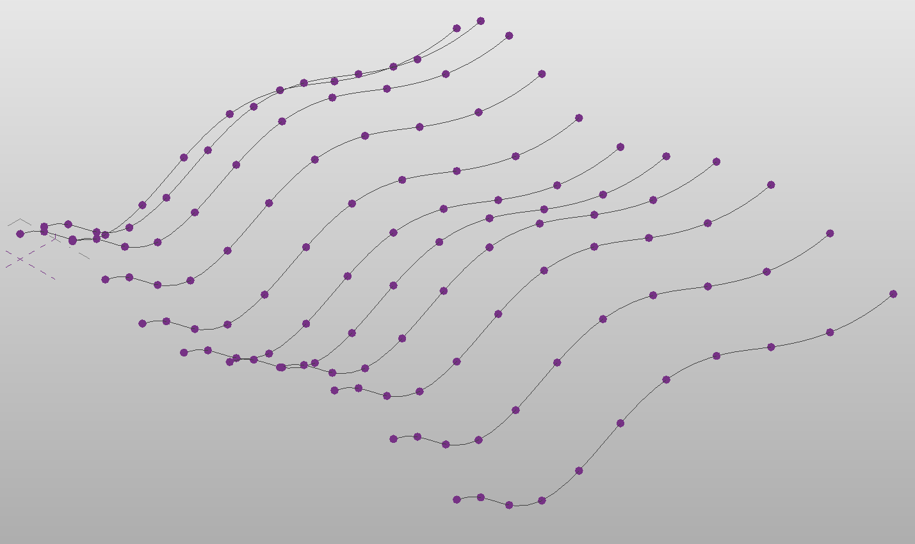 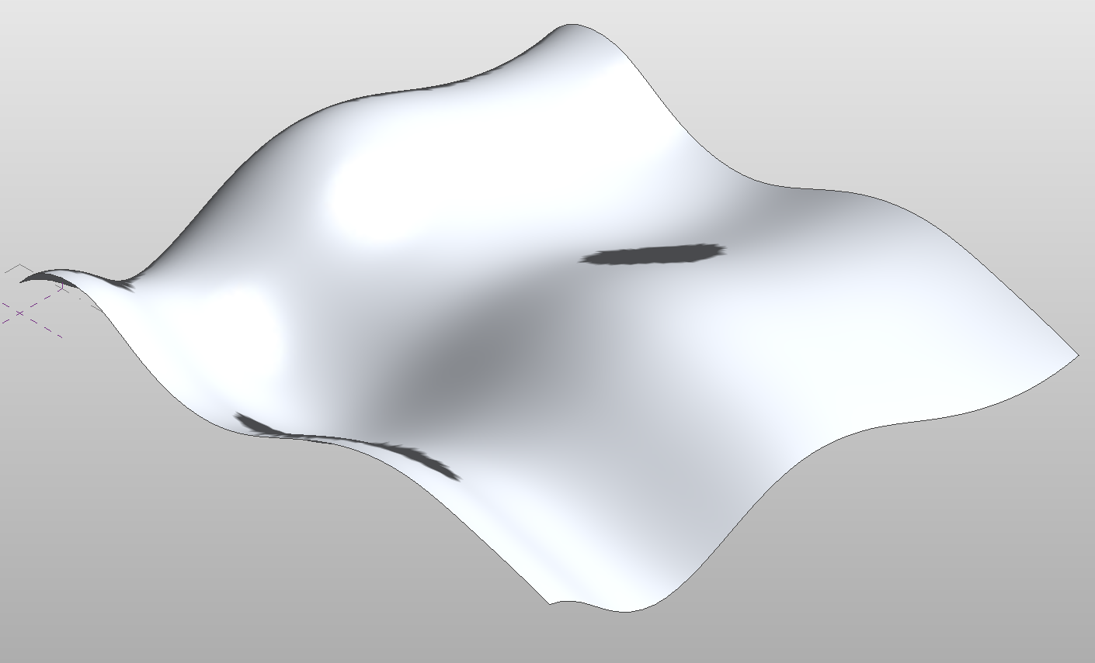

4. Spiral Elements

Uses: “SpiralArc.csv", "SpiralGrid.csv", "SpiralLine.csv", and "SpiralWall.csv"

Test File: “C-SharpSpirals2018.rvt”

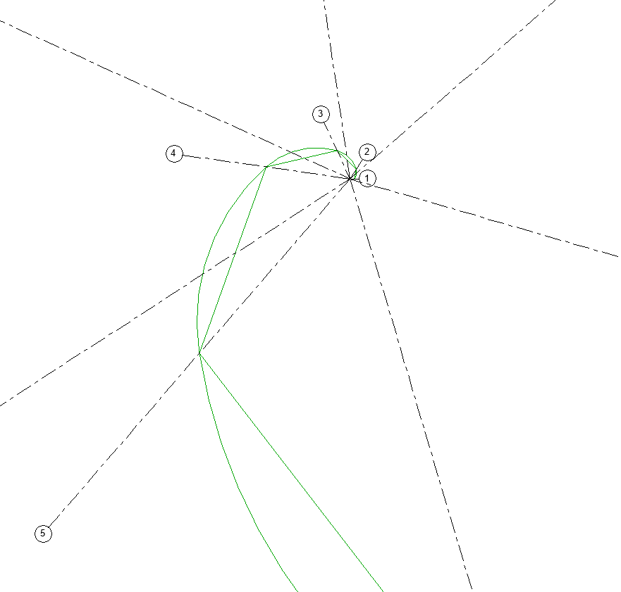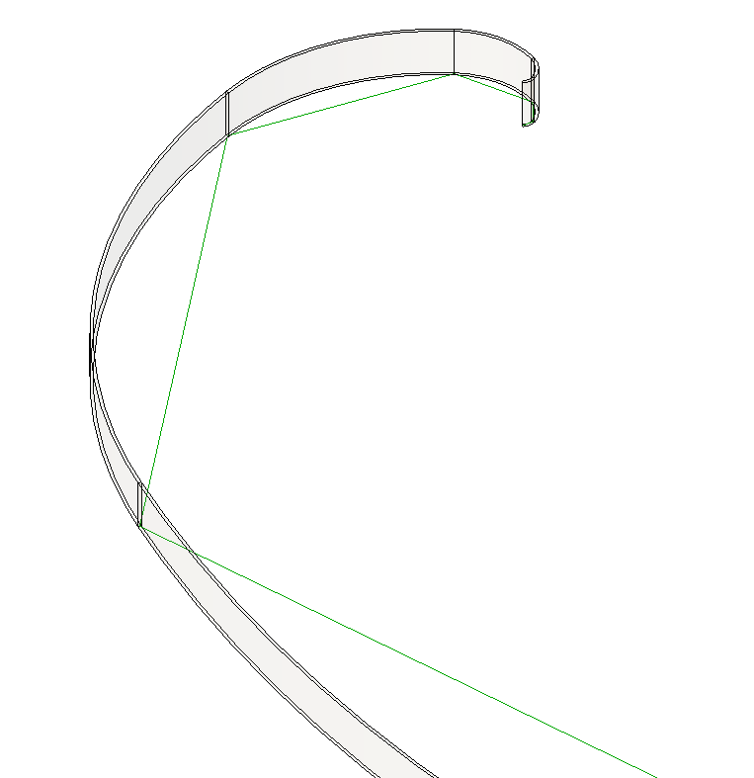

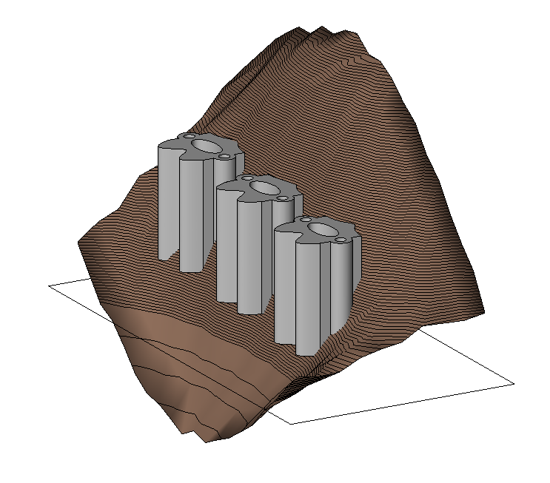

5. Site Elements

Uses: “Buildings.csv", and "TopoSurf.csv"

Test File: “C-SharpSite2018.rvt”

To create the buildings the paths must be set in the Revit-ModelBuilder

